

National Cancer Institute
Center for Biomedical Informatics
and Information Technology
(CBIIT)
Anonymous User Login/Design Notes
Last Revised: | Feb 6, 2009
Produced By: | NCIA Team
Version: | 1.0
Contents
Summary 3
Design/Implementation Notes 3
Changes 3
Configurations 3
UI Changes 3
Backing Bean 5
Data basket 6
Result Page 6
Error Messages 6
Builds 6

Summary
The main purpose of this task is to allow user to search for NCIA public data without having to register and login into NCIA. The system will also warn user that they will not be able to download more than 3GB of data.

Design/Implementation Notes

Changes

Configurations
Three additional properties are added to the properties-services.xml:
- Guest_username: to store the guess username after it’s created using UPT.
- Guest_password: to store the guess user password after it’s created using UPT.
- Enabled_guest_account: by default, set it to “no” meaning anonymous user cannot access NCIA search feature without login in. “yes” meaning anonymous user is allowed to search NCIA repositories without login into the system. In this case, guest account is used for login.
- We might also need to create an LDAP guest account.

UI Changes
The following changes are required when enabled_guest_account is set to “yes”:
- Create new page that allows user to search public data without login into NCIA. This page also contains a links to the login, register and support sections if user chooses to login, register or need to contact system support team.
- Subview is needed to show the user id and password input box when login link is clicked.
- A new subview is created to show the current login screen if guest account is disabled.
- When user clicks on the register link, redirect to the register page.
- The top portion of the main screen contains descriptive information about NCIA.
- The bottom portion contains a table with links to search page.
- The search is Local instance search only.
- Disable the save query and history menu on the result page.

The following screens show the home page when guest account is enabled.
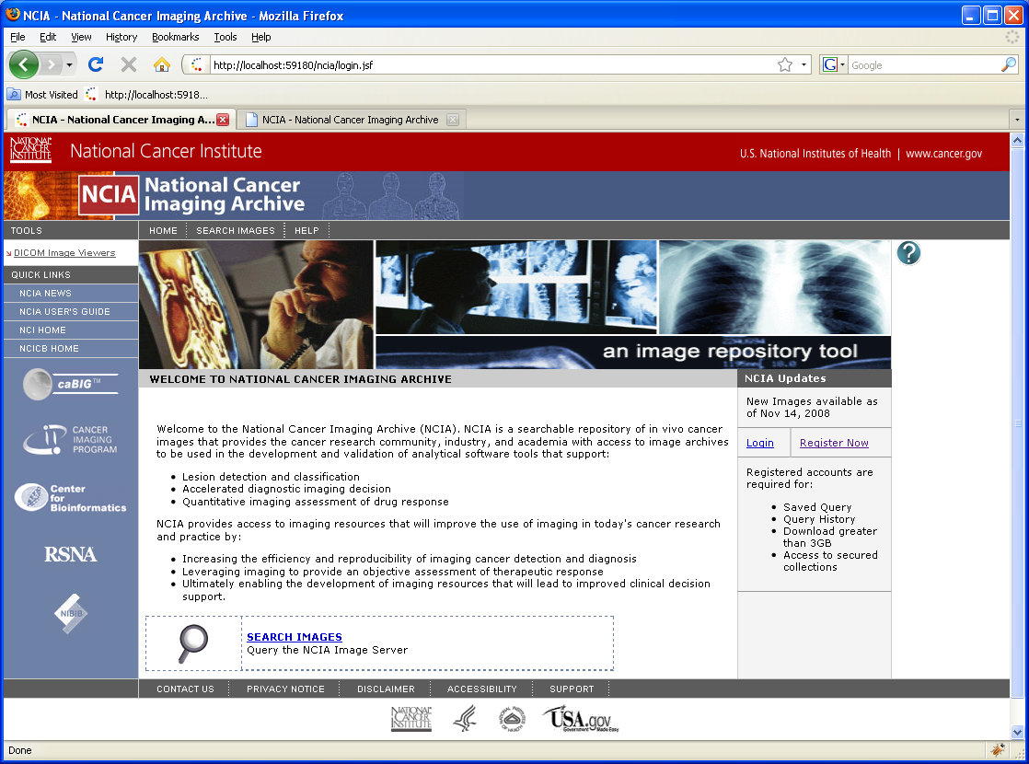

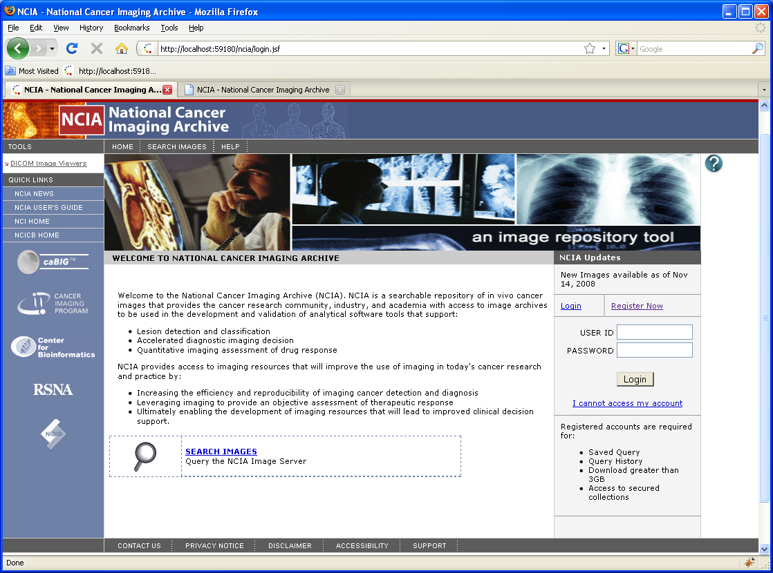
When guest account is set to “no”, current logic to show UI is modified to show the current login screen.

Backing Bean
- AnonymousLoginBean is created to get the guest_account properties from application server, and display the appropriate view on the UI based on its value and to contain any logic regarding guest account.
- When drill down to study and series, image level, need to check for guest account and size of data basket when user add data to basket to ensure that it is not larger than 3GB.
- Need to disable save query and history codes after the search for guest user. Currently, the save query and history links are shown when user logged in, this logic needs to be modified to not show it in case user is logged in as a guest.
- Need to disable login history after logged in. Security Bean needs to be modified to accomplish this. If possible, this code can be moved to AnonymousLoginBean.

Data basket
Each time user attempt to add more data into their basket, check for the current size of the basket and do not allow them to add when the size is larger than 3GB and display a warning message to let user knows that their data basket is full. If they want to download more than 3GB, then they will need to login. Data basket bean and page will need to be modified for this.

Result Page
- searchResult, studyResult, seriesResult pages will be modified accordingly to the bean.
- At study level, need to add logic to disable “Visualize” images button for guest user.

Error Messages
Display the following error when guest_username and password is missing and enabled_guest_account is enabled or guest username/passoword is incorrect.
“The system cannot log you in due to configuration errors, please contact application support for assistance.”
Or “The system cannot log you in, please contact application support for assistance.”

Builds
The NCIA build will need to be modified to include new properties and set the enabled_guest_account value to “no” as default.

